Graph Model

🔗 What is the Graph Data Model?
# Source: AI Source: Provided by: [Data Path: Persons Table -> ID Column: 1, Name_En Column: Motasem Essam] -> From: [ChatGPT] on [6/10/2026]
The Graph Model is a data model that represents data as a set of nodes (entities) and edges (relationships). It is ideal for scenarios where relationships between data are as important as the data itself.

🧠 Core Concepts
# Source: AI Source: Provided by: [Data Path: Persons Table -> ID Column: 1, Name_En Column: Motasem Essam] -> From: [ChatGPT] on [6/10/2026]
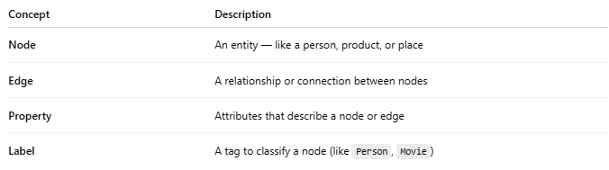
Concept | Description
Node | An entity — like a person, product, or place
Edge | A relationship or connection between nodes
Property | Attributes that describe a node or edge
Label | A tag to classify a node (like Person, Movie)

🧾 Example: Social Network
# Source: AI Source: Provided by: [Data Path: Persons Table -> ID Column: 1, Name_En Column: Motasem Essam] -> From: [ChatGPT] on [6/10/2026]
Imagine Alice follows Bob on a social platform.
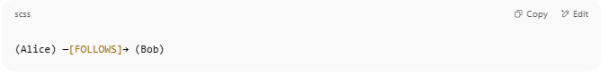
(Alice) —[FOLLOWS]→ (Bob)

- Nodes: Alice, Bob
- Edge: FOLLOWS
- Properties: Alice.age = 24, FOLLOWS.since = "2023-01-01"

📊 Visual Example
# Source: AI Source: Provided by: [Data Path: Persons Table -> ID Column: 1, Name_En Column: Motasem Essam] -> From: [ChatGPT] on [6/10/2026]
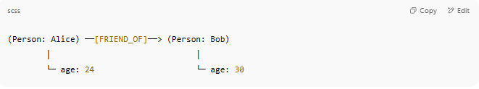
(Person: Alice) ──[FRIEND_OF]──> (Person: Bob)
│ │
└─ age: 24 └─ age: 30

🔍 Query Language Example (Cypher - Neo4j)
# Source: AI Source: Provided by: [Data Path: Persons Table -> ID Column: 1, Name_En Column: Motasem Essam] -> From: [ChatGPT] on [6/10/2026]
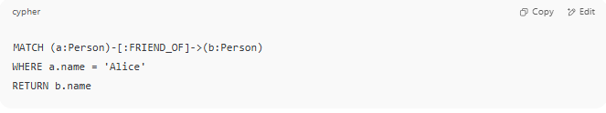
MATCH (a:Person)-[:FRIEND_OF]->(b:Person)
WHERE a.name = 'Alice'
RETURN b.name

✅ This finds all people that Alice is friends with.

✅ Advantages of Graph Model
# Source: AI Source: Provided by: [Data Path: Persons Table -> ID Column: 1, Name_En Column: Motasem Essam] -> From: [ChatGPT] on [6/10/2026]
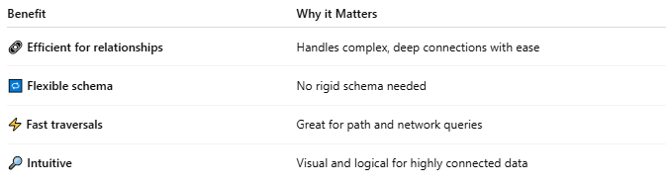
Benefit | Why it Matters
🔗 Efficient for relationships | Handles complex, deep connections with ease
🔁 Flexible schema | No rigid schema needed
⚡ Fast traversals | Great for path and network queries
🔎 Intuitive | Visual and logical for highly connected data

❌ Disadvantages
# Source: AI Source: Provided by: [Data Path: Persons Table -> ID Column: 1, Name_En Column: Motasem Essam] -> From: [ChatGPT] on [6/10/2026]
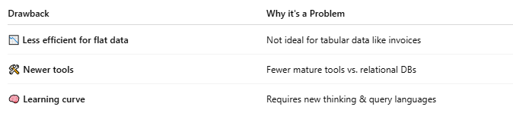
Drawback | Why it's a Problem
📉 Less efficient for flat data | Not ideal for tabular data like invoices
🛠️ Newer tools | Fewer mature tools vs. relational DBs
🧠 Learning curve | Requires new thinking & query languages

🛠 Popular Graph Databases
# Source: AI Source: Provided by: [Data Path: Persons Table -> ID Column: 1, Name_En Column: Motasem Essam] -> From: [ChatGPT] on [6/10/2026]
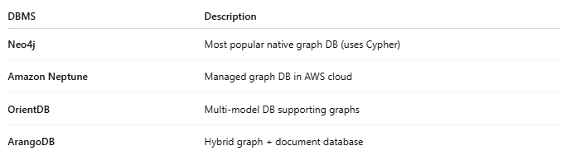
DBMS | Description
Neo4j | Most popular native graph DB (uses Cypher)
Amazon Neptune | Managed graph DB in AWS cloud
OrientDB | Multi-model DB supporting graphs
ArangoDB | Hybrid graph + document database

📚 Use Cases
# Source: AI Source: Provided by: [Data Path: Persons Table -> ID Column: 1, Name_En Column: Motasem Essam] -> From: [ChatGPT] on [6/10/2026]
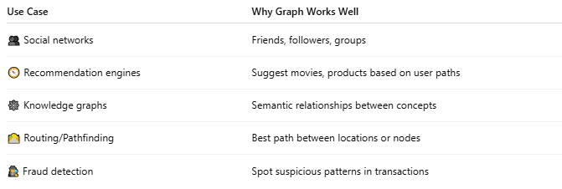
Use Case | Why Graph Works Well
👥 Social networks | Friends, followers, groups
🧭 Recommendation engines | Suggest movies, products based on user paths
🕸️ Knowledge graphs | Semantic relationships between concepts
🛣️ Routing/Pathfinding | Best path between locations or nodes
🕵️ Fraud detection | Spot suspicious patterns in transactions

Difference between Graph Model and Network Model
# Source: AI Source: Provided by: [Data Path: Persons Table -> ID Column: 1, Name_En Column: Motasem Essam] -> From: [ChatGPT] on [6/10/2026]
Great question! Let's compare the Graph Model and the Network Model — both deal with relationships, but they come from very different generations of database technology and design philosophies.

📘 Side-by-Side Comparison: Graph Model vs Network Model
# Source: AI Source: Provided by: [Data Path: Persons Table -> ID Column: 1, Name_En Column: Motasem Essam] -> From: [ChatGPT] on [6/10/2026]
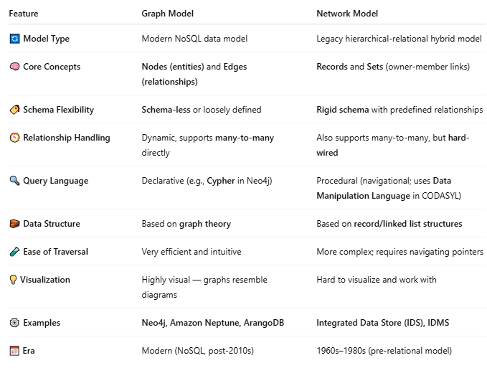
Feature | Graph Model | Network Model
🔄 Model Type | Modern NoSQL data model | Legacy hierarchical-relational hybrid model
🧠 Core Concepts | Nodes (entities) and Edges (relationships) | Records and Sets (owner-member links)
🏷️ Schema Flexibility | Schema-less or loosely defined | Rigid schema with predefined relationships
🧭 Relationship Handling | Dynamic, supports many-to-many directly | Also supports many-to-many, but hard-wired
🔍 Query Language | Declarative (e.g., Cypher in Neo4j) | Procedural (navigational; uses Data Manipulation Language in CODASYL)
🧱 Data Structure | Based on graph theory | Based on record/linked list structures
🧪 Ease of Traversal | Very efficient and intuitive | More complex; requires navigating pointers
💡 Visualization | Highly visual — graphs resemble diagrams | Hard to visualize and work with
⚙️ Examples | Neo4j, Amazon Neptune, ArangoDB | Integrated Data Store (IDS), IDMS
📅 Era | Modern (NoSQL, post-2010s) | 1960s–1980s (pre-relational model)

🧠 Example Illustration

🌐 Graph Model (Neo4j-style)
# Source: AI Source: Provided by: [Data Path: Persons Table -> ID Column: 1, Name_En Column: Motasem Essam] -> From: [ChatGPT] on [6/10/2026]
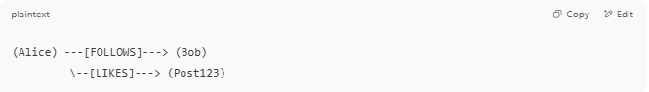
(Alice) ---[FOLLOWS]---> (Bob)
\--[LIKES]---> (Post123)

- Nodes = Alice, Bob, Post123
- Edges = FOLLOWS, LIKES
- Each element can have properties (age, time, etc.)

📚 Network Model
# Source: AI Source: Provided by: [Data Path: Persons Table -> ID Column: 1, Name_En Column: Motasem Essam] -> From: [ChatGPT] on [6/10/2026]

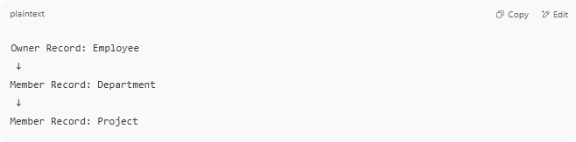
Owner Record: Employee
↓
Member Record: Department
↓
Member Record: Project

- You must navigate through the structure step-by-step.
- You can’t query like: “Get all employees in projects with budget > 1M” easily.

📈 Diagram: Graph Model vs Network Model
# Source: AI Source: Provided by: [Data Path: Persons Table -> ID Column: 1, Name_En Column: Motasem Essam] -> From: [ChatGPT] on [6/10/2026]
Here's a diagram comparing the Graph Model vs Network Model visually:

1️⃣ Graph Model (Modern – Neo4j Style)
# Source: AI Source: Provided by: [Data Path: Persons Table -> ID Column: 1, Name_En Column: Motasem Essam] -> From: [ChatGPT] on [6/10/2026]
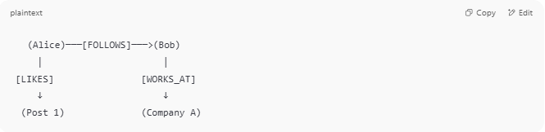
(Alice)───[FOLLOWS]───>(Bob)
│ │
[LIKES] [WORKS_AT]
↓ ↓
(Post 1) (Company A)

- 🔵 Nodes: Alice, Bob, Post 1, Company A
- 🔗 Edges: FOLLOWS, LIKES, WORKS_AT
- 🏷 Properties can be on both nodes and edges
- ➕ Relationships can be queried in any direction

2️⃣ Network Model (Legacy – CODASYL Style)
# Source: AI Source: Provided by: [Data Path: Persons Table -> ID Column: 1, Name_En Column: Motasem Essam] -> From: [ChatGPT] on [6/10/2026]
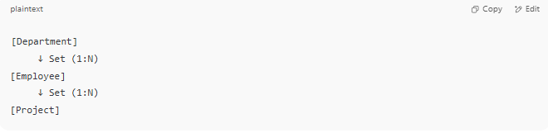
[Department]
↓ Set (1:N)
[Employee]
↓ Set (1:N)
[Project]

- 📂 Records: Department, Employee, Project
- ➡️ Sets define owner/member (parent-child) relationships
- 🔁 Navigation is step-by-step, not ad-hoc
- 💡 You must know how to traverse the structure

🧠 Key Takeaways from the Diagram
# Source: AI Source: Provided by: [Data Path: Persons Table -> ID Column: 1, Name_En Column: Motasem Essam] -> From: [ChatGPT] on [6/10/2026]
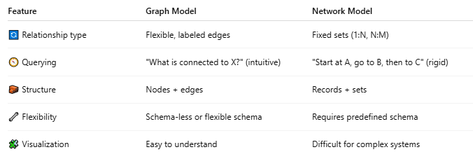
Feature | Graph Model | Network Model
🔄 Relationship type | Flexible, labeled edges | Fixed sets (1:N, N:M)
🧭 Querying | "What is connected to X?" (intuitive) | "Start at A, go to B, then to C" (rigid)
🧱 Structure | Nodes + edges | Records + sets
🔧 Flexibility | Schema-less or flexible schema | Requires predefined schema
🧩 Visualization | Easy to understand | Difficult for complex systems

🆚 A visual diagram comparing Graph Model vs Network Model
# Source: AI Source: Provided by: [Data Path: Persons Table -> ID Column: 1, Name_En Column: Motasem Essam] -> From: [ChatGPT] on [6/10/2026]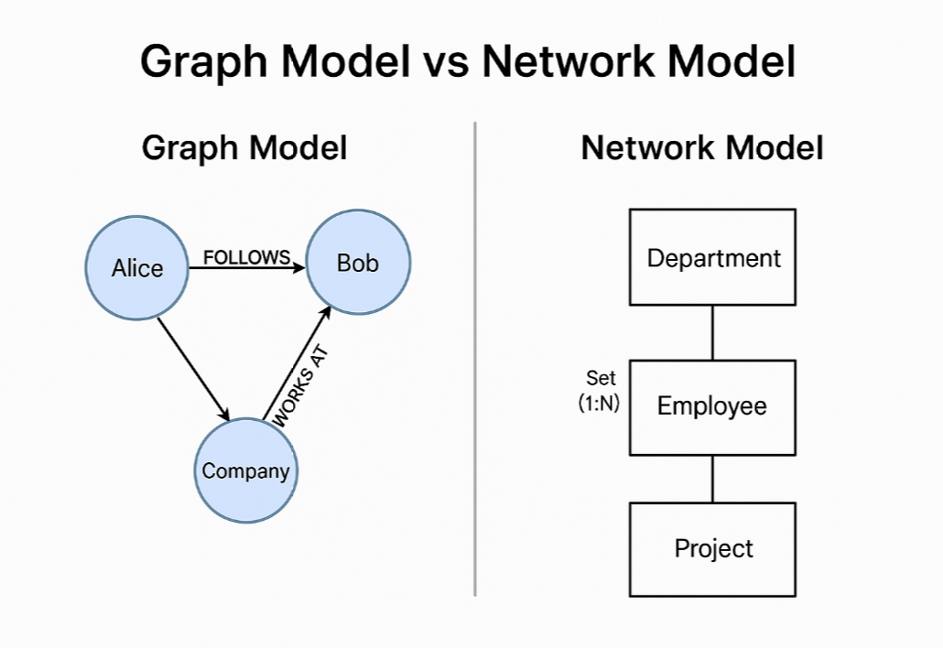

✅ Summary
# Source: AI Source: Provided by: [Data Path: Persons Table -> ID Column: 1, Name_En Column: Motasem Essam] -> From: [ChatGPT] on [6/10/2026]
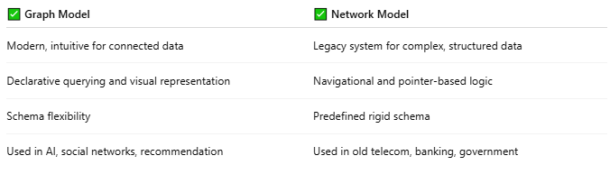
✅ Graph Model | ✅ Network Model
Modern, intuitive for connected data | Legacy system for complex, structured data
Declarative querying and visual representation | Navigational and pointer-based logic
Schema flexibility | Predefined rigid schema
Used in AI, social networks, recommendation | Used in old telecom, banking, government

🚦Conclusion
# Source: AI Source: Provided by: [Data Path: Persons Table -> ID Column: 1, Name_En Column: Motasem Essam] -> From: [ChatGPT] on [6/10/2026]
- ✅ Use Graph Model if you're building modern apps with complex relationships (like social media, recommendations, fraud detection).
- 🛑 Avoid using Network Model unless you're studying database history or maintaining a legacy system.

🧠 Summary
# Source: AI Source: Provided by: [Data Path: Persons Table -> ID Column: 1, Name_En Column: Motasem Essam] -> From: [ChatGPT] on [6/10/2026]
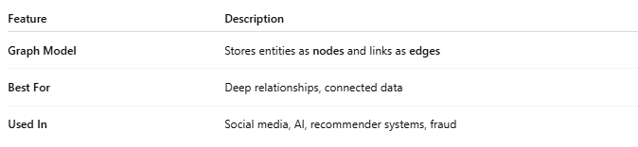
Feature | Description
Graph Model | Stores entities as nodes and links as edges
Best For | Deep relationships, connected data
Used In | Social media, AI, recommender systems, fraud

